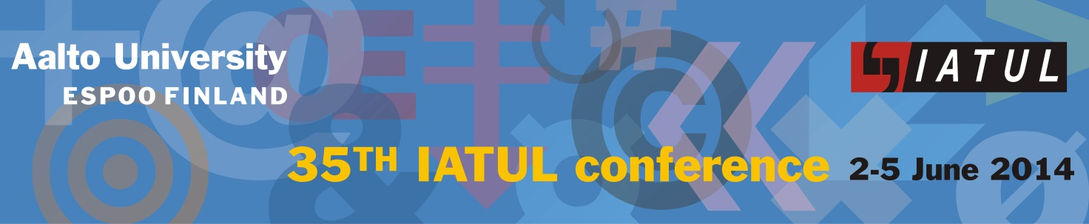

“Measures for Success

– Library Resources and Effectiveness under Scrutiny”

SPONSORSHIP FORM

COMPANY NAME: ………………………………………………………………………………………..
ADDRESS: ………………………………………………………………………………………………….
WEB SITE ADDRESS: …………………………………………………………………………………..
CONTACT PERSON: …………………………………………..…………………………………………
POSITION / TITLE: …………………………………………………………………………………….
PHONE: ……………………………………….. FAX: …………………………………………..
EMAIL: ………………….…………………………………………………………………………………..
[Company name]
…………………………………………………………………………………………… commits to
sponsor the IATUL 2014 Conference at the level indicated below:

□ Platinum Sponsor

□ Gold Sponsor

□ Silver Sponsor

□ Bronze

□ Donor Sponsor (EUR __________)

Special requirements:
□ ……………… □ Reserve Exhibit Space (at Platinum or Gold Levels)
Yes No
□ ……………… □ Provide logo image for program and display at conference
Yes No
ACTIVITY/EVENT TO BE SPONSORED: ………………………………………………………...
…………………………………………………………..
[signature]

Address questions and submit this form to:
Irma Pasanen, Conference Convener, Associate Library Director for Information Services, Aalto University, P.O. Box 17 000, 00076 Aalto, Finland
Email: Irma.Pasanen@aalto.fi

